Interim Lancashire Place Based Partnership Board

Locality Workshops
- Background

As part of the development of the Lancashire Place Based Partnership, it was agreed to hold a series of workshops within each locality (Central, North and East) during January – March to undertake a period of wider engagement with our partners on our emerging thinking, to help us understand where we need to change, adapt and further iterate our thinking upon the following:

- Reflect and comment on our journey to date and the way the Lancashire Place is shaping up.
- Listen to feedback on the emerging themes and responses to those from a sector / organisational / directorate perspective.
- Understand what is already happening within our communities.
- Identify how we can collaborate effectively as a system, place, and communities to support and empower more positive case studies.
- How can lessons learned facilitate successful integration and partnership working?

The workshops were engaging, informal and set the tone for how we propose to work with our stakeholders across the Lancashire Place to build relationships and support future arrangements. Tailored towards each locality the following workshops took place:

Locality | Date
North Lancashire (Lancaster) | 18 January 2023
Central Lancashire | 31 January 2023
North Lancashire (Fylde & Wyre) | 01 February 2023
East Lancashire x 2 | 08 February 2023 (am & pm)

An additional Lancashire wide session took place on the 22nd March which provided an opportunity for stakeholders to receive an update upon actions taken already as a result of the feedback from previous sessions.

Representation across all the workshops was high with over 168 delegates in attendance and 13 sectors represented via 47 indvidual organisations from the following core partners:

- Providers of primary care services
- Providers of community services (physical health)
- Voluntary and Community, Faith and Social Enterprise Sector providers
- Providers of social and home care services
- Hospices and Providers of acute services
- Providers of mental health services
- Lancashire and South Cumbria Integrated Care Board
- Lancashire County Council
- District Councils

- Stakeholder Feedback

Throughout the workshops we heard the importance of our communities, in particular:

- We heard the importance of communities and the need to focus upon our neighbourhoods.
- We listened to the integral role of our District Councils and their collaborative work with partners and engagement with communities.
- We heard that we should build upon existing partnership arrangements to ensure the avoidance of duplication and preventing reinventing the wheel.

The feedback collated across all the workshops is outlined in the table on page 4 with associated actions that we have taken or intend to take as a result.

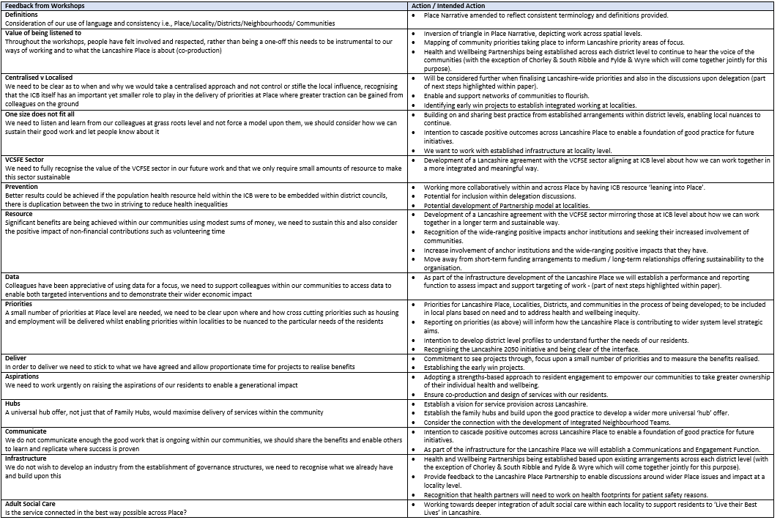

Based upon the engagement and feedback collated from the workshops we have designed our locality arrangements with these principles in mind (built from communities, with a focal point around districts and using existing arrangements where possible), outlined below:

- Translate strategic agreement into operational delivery to improve lives and the wellbeing of the whole population; places are all age.
- Influence the wider Place by providing feedback to the Lancashire Place Partnership via a forum(s) to discuss wider Place issues and how they impact at a locality level.
- Enable and support networks of communities to flourish – supporting an asset and strengths based approach to support
- Ensure that Lancashire wide priorities are included in local plans based on need.
- Enable local priorities to be developed, delivered and recognised to address health and wellbeing inequity.
- Undertake performance management to assess impact and support targeting of work.
- Where appropriate provide an interface to ‘health integration’ agenda; recognising that health partners will need to work on ‘health footprints’ for patient safety reasons.

- Recommendation/s

Members of the Interim Lancashire Place Based Partnership Board were asked to approve the feedback and associated actions and intended actions from the series of workshops held across each locality within the Lancashire Place.

The above recommendation was approved at the 24 April 2023 meeting of the Interim Lancashire Place Board.

